43.71: Mass of 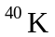 atoms in 1.00 kg is
Number of atoms 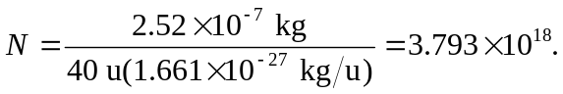
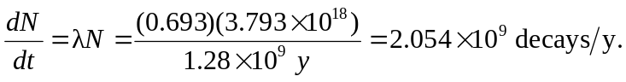
So in 50 years the energy absorbed is:
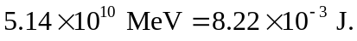 So the absorbed dose is 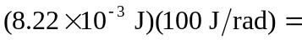 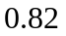rad and since the RBE = 1.0, the equivalent dose is 0.82 rem.

